Easter Plants from the Ottawa Y Service club. 2021.

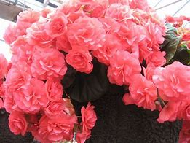  Reiger Begonia. 6” pot $14.25 | 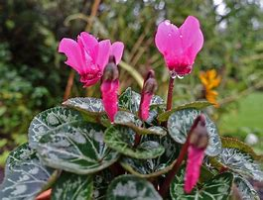  Cyclamen assorted. 6” pot $12.50 | Anthurium. 5” pot $16.00
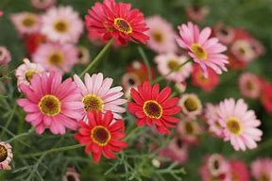  Gerbera. (African Daisy).  6” pot $11.75 | 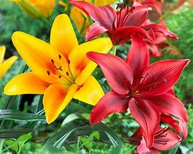 Oriental Lily. 6” pot. $14.25 | 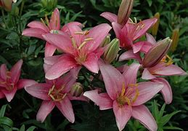  Pixie Lily. 6” pot $10.75.
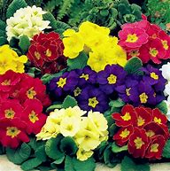  Primula (Primrose).  4” pot. $4.25. | 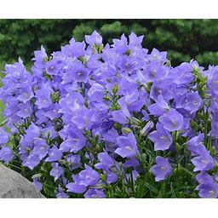Campanula. (Bellflower),  4” pot. $9.25 | 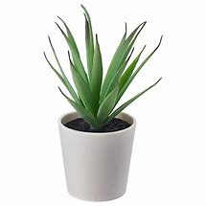  Aloe Vera plus Succulents and Hens and Chicks at $7

