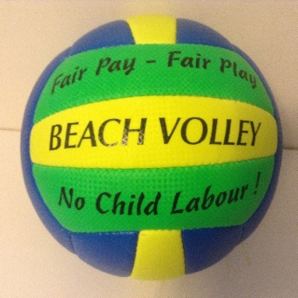 | 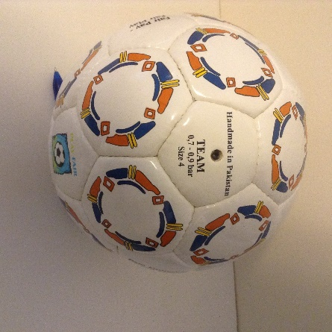 | 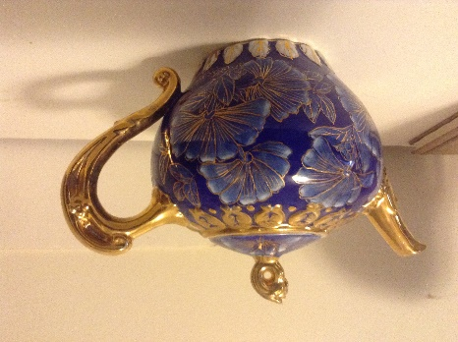
#13 5 Fair Trade Beach Volleyballs @ $12 each | #14. Fair Trade soccer ball size 4. $15 | #15. Large decorative teapot, $20
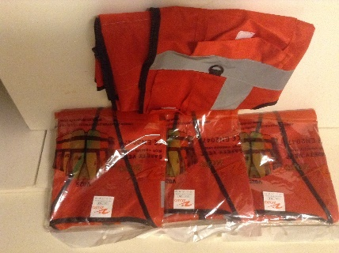 | 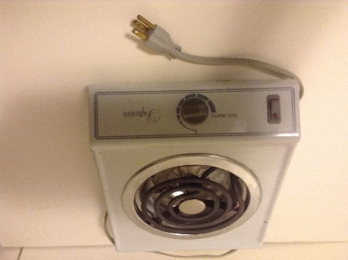 | 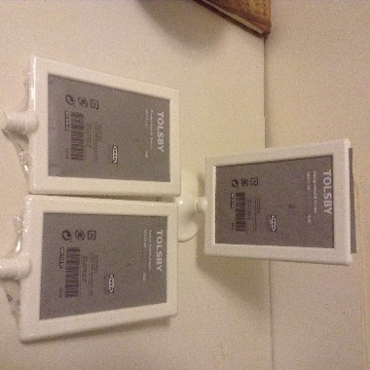
#16. 4 XL red vests @ $10 ea | #17. Electric Hot plate. $12 | #18. Set of 3 photo holders. $10
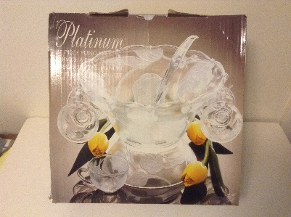 | 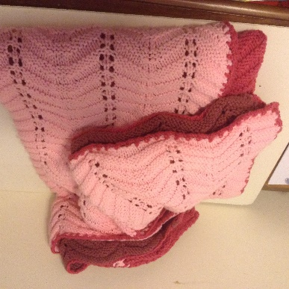 | 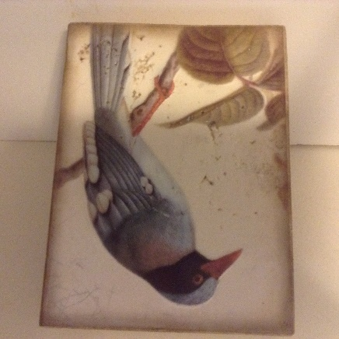
#19. 27 piece punch bowl. $40 | #20. Full size Afghan $50 | #21. Decorative wall block $60
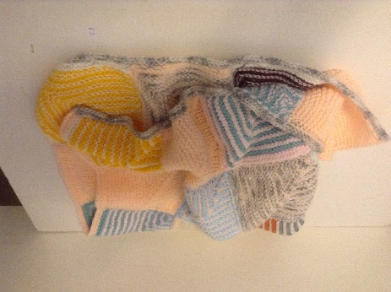 | 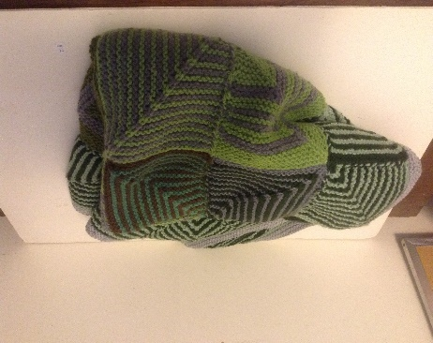 | 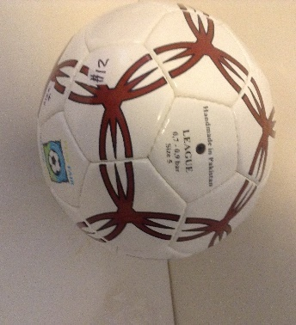
#22 Baby Afghan. $20 | #23. Large Afghan. $40 | #24 Fair Trade soccer ball size 4  $15

