 | 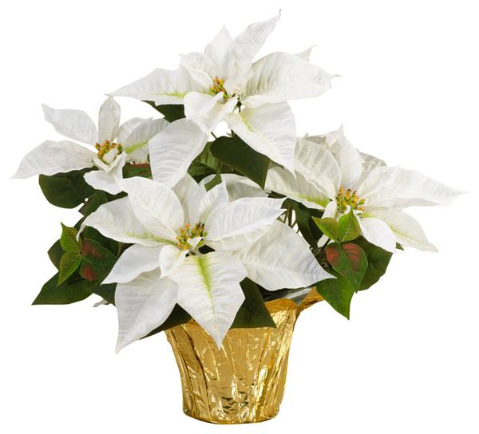 | a
Poinsettia Red  4.5” $ 6.75  6” $13.75  8” (three plants) $32.50 | Poinsettia White  6” $13.75 | Poinsettia Variegated  6” $13.75
 | 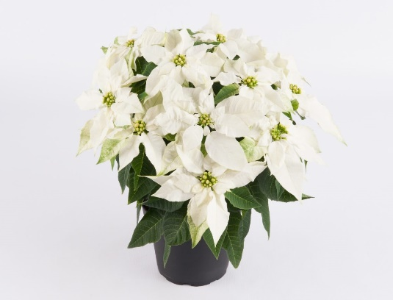
Mumsettia 7” $16.25 | Princettia White 6” $16.00 | Frosty Fern 4” $9.00
Christmas Cactus 4” $ 6.25  6” $13.00 | Azalea 6” $24.00 | Cyclamen 6” $12.00
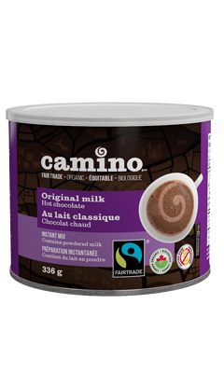  Fair Trade | 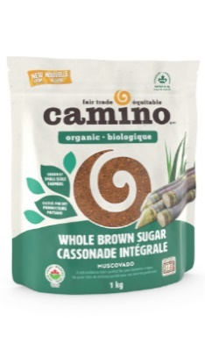 | 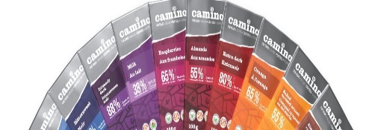
Camino Hot Chocolate 336g $6.00  (Original Milk, Original Dark,  Chili and Spice) | Camino Brown Sugar 1 Kg $5.00 | Camino Chocolate Bars 100g  $ 4.50 ea 3 for $12.00  (see order form for choices)

