Kitchissippi Men’s Book Club Reviews - May 2021

BOOK: What I Remember, What I Know
The Life of a High Arctic Exile
By Larry Audlaluk
Review by Russ Mills

In August 1953, the RCMP, acting as the representatives of the federal Department of Resources and Development, transported seven or eight Inuit families from Inukjuak, former called Port Harrison, in Northern Quebec, 2000 kilometres north to the islands in the High Arctic. They were resettled in Grise Fiord on Ellesmere Island and in Resolute on Cornwallis Island. The resettlement locations were as far north of their previous homes in Quebec as Ottawa is north from Jacksonville, Florida. The new settlements had a much colder climate, a different ecosystem with different game animals for hunting and three months of darkness each year.

At the time of the relocation, author Larry Audlaluk was a three-year-old child in one of the relocated families. His personal memories of this are obviously slim because of his age at the time of the move but he recounts in the impact on his community in this well-written book. The Inuit had been assured plentiful wildlife but soon discovered that they had been misled, and endured many hardships.

The relocation has been a source of controversy. The federal government defended it as a humanitarian gesture to save the lives of starving indigenous people and enable them to continue a subsistence lifestyle based on hunting. Critics saw it as a forced migration instigated by the federal government to assert Canadian sovereignty in the far north with the use of “human flagpoles” in light of both the Cold War and disputed claims to the Canadian Arctic Archipelago. Both sides acknowledge that the Inuit were not given sufficient support to prevent extreme privation during their first years after the move.

Many years later, following public and media pressure, the federal government created a program to assist the Inuit to return to the south. In 1989, 40 Inuit returned to their former communities, leading to a break up in families along generational lines, as younger community members often chose to remain in the High Arctic. Author Larry Audlaluk was one of those who chose to stay in the far north. Since he had arrived there as a three-year-old, it was the only home he knew.

In 1994, the Royal Commission on Aboriginal Peoples held hearings to investigate the relocation program. The Commission recommended an apology and compensation for the survivors, as well as acknowledgement of the role the relocates played in establishing a Canadian presence in the High Arctic. The federal government refused to apologize but established a “Reconciliation Agreement” in 1996 and created a $10 million trust fund for relocated individuals and their families.

In 2010, after almost five decades of controversy, the Harper government finally issued an official apology. It stated: “The Government of Canada deeply regrets the mistakes and broken promises of this dark chapter of our history and apologizes for the High Arctic relocation. The relocation of Inuit families to the High Arctic is a tragic chapter in Canada’s history that we should not forget.”

Larry Audlaluk’s book is a highly personal account of the impact of the relocation on himself, his family and his community. It brings deeper understanding of this dark episode in Canada’s past.

Discussion

Russ further described the views of the late Gordon Robertson, a leading federal public servant who became Deputy Minister of Northern Affairs and Commissioner of the Northwest Territories some three months after the relocation took place, based on Gordon’s memoir and Russ’s own conversations with him. Gordon felt that the officials who organized the relocation did so primarily because of food security concerns on the northern Quebec coast and were not doing so against the will of the people who were moved.

Some participants thought that concerns over Canadian sovereignty, and possible incursion by the Soviets, must have been motivating factors; the DEW line was built soon after. Russ noted that current notions of consent were not practised in the 1950s.

Grise Fiord and Resolute are located thousands of kilometers from the Quebec coast, in what is effectively a northern desert. They persist today as highly isolated, small communities in a hostile environment, as Mike Lawlor, who visited them in the 1970s, observed .

BOOK- UMIMGMAK
Stuart Hodgson and the Birth of the Modern Arctic
By Jake Ootes
Review by Mike Lawlor
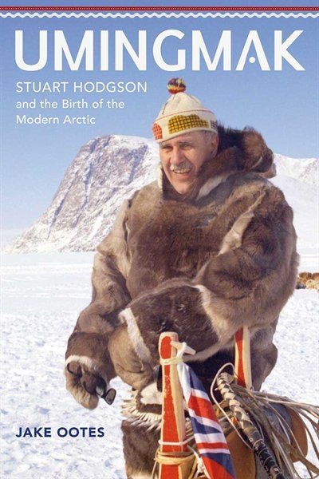
Mike Lawlor reviewed a related book, Umingmak, an account of the modernization of the north in the 1970s, under the leadership of Stuart Hodgson, the first resident Commissioner of the Northwest Territories. From 1967 to 1979 Hodgson oversaw the development of responsible local government in Canada’s north. He established a network of municipal governments and left a legacy that ultimately turned administrative and political power over to the people of the North, including scheduled airlines, radio, telephone, and TV service; where children were no longer sent away for primary schooling, improved housing, water, and sanitary services; and where perishable food became available in most communities.

Our visitors Nancy Brodie and Jane Craig noted that the discussion was particularly interesting with people who had some first-hand knowledge of the north and the characters in the books.

BOOK: UMIMGMAK
Stuart Hodgson and the Birth of the Modern Arctic
By Jake Ootes (2020) Director of the NWT Department of Education.
Review by Doug Patriquin

With his tribute to Claire M. Barney of Vanier, Ontario “The greatest Northerner of all of them” Stuart Hodgson was the 1st resident commissioner of the NWT. He was appointed by PM Pearson in 1967 as the NWT capital moved from Ottawa to Yellowknife. The NWT formed one-third of geographical Canada; 50 isolated communities scattered over 1,300,000 square miles and primarily populated with “Eskimos, Indians, and Métis”; (the nomenclature at the time).

From 1967 to 1979 Hodgson oversaw the development of, and laid the foundation, for responsible local government. During Hodgson’s time in office, Northerners took an increasing role in making decisions that affected them. The Council of NWT transitioned from federally appointed bureaucrats to a fully-elected Legislative Assembly. In doing so Hodgson developed the infrastructure and he secured the equipment needed to support the newly formed local and territorial governments.

Hodgson left a legacy that turned administrative and political power over to the people of the North. He created a northern modern territory that: included scheduled airlines; radio, telephone, and TV service; where children were no longer sent away for primary schooling, improved housing, water, and sanitary services; where perishable food was available in most communities. With the cooperation of the Yukon, Hodgson developed and organized the Arctic Winter Games as a lasting tribute to sport in the Canadian Arctic.

Hodgson balanced the aspirations of the Dene; Inuit; Métis; and the non-Indigenous residents:. He fundamentally shaped the NWT and Nunavut. Hodgson was made an Officer of the Order of Canada.

As a follow up to Larry Audlaluk’s book on Inuit settlements in the 1950s, Mike Lawlor will review a recent book on Stuart Hodgson, the first resident Commissioner of the NWT. Mike worked in Yellowknife when Hodgson was there in the late 1970s (as did I).

